The Advanced British Standard
Our plans to change education for 16 to 19 year old students
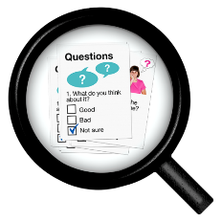
Survey
Tell us what you think by
20 March 2024.
What this survey is about.
We are the Department for Education,
part of the UK government.
We make sure all children and young people get a good education.
The Advanced British Standard is a new type of qualification for students aged 16 to 19 years old.
We call it the ABS for short.
Our ABS guidance booklet in Easy Read tells you about our plans for the ABS.
Please read it before you do this survey.
Tell us what you think about our plans
for the ABS by filling in this survey.
We will use what you tell us to make our plans better.
This is the Easy Read version of the Advanced British Standard consultation.
When you have finished, please email your Word survey to ABS.consultation@education.gov.uk
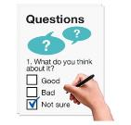
Or you can print and fill in the paper survey. Then post it to
Advanced British Standard Consultation Team
Department for Education
Sanctuary Buildings
20 Great Smith Street
London SW1P 3BT
You can also fill in the standard survey on our website at https://consult.education.gov.uk/advanced-british-standards-directorate/the-advanced-british-standard/
The standard survey is not in Easy Read.
If you have any questions about this consultation or survey you can email ABS.consultation@education.gov.uk
Please send us your answers by
20 March 2024.
You can miss out any questions that you
do not want to answer.
Questions about you

Question 1.
What is your name?
Write here
Question 2.
What is your email address?
We are asking for it so we can contact you if
we want to know more about your answers.
You do not have to give us your email.
Write here

Question 3.
Are you happy for us to email you about your answers?
 | Yes | ☐
 | No | ☐

Question 4.
Are you doing this survey for
 | - yourself? | ☒
 | - an organisation?  Like a charity. | ☐

If you are doing this survey for yourself, go to question 7.
If you are doing this survey for an organisation, please now answer question 5 and question 6.

Question 5.
Only answer if you are doing this survey
for an organisation.
What is your organisation called?
Write here

Question 6.
Only answer if you are doing this survey
for an organisation.
What do you do in the organisation?
Write here

Please now go to question 8.

Question 7.
Only answer if you are doing this survey for yourself.
Tick 1 box that is the most important for this survey.
Are you…
 | A student, pupil, or learner? | ☐
 | A parent or carer? | ☐
 | A teacher, tutor, or lecturer? | ☐
 | A researcher or education expert? | ☐
 | An employer? | ☐
 | Someone who advises people about  jobs and work? | ☐
 | Something else?  Tell us in the box below. | ☐
 | Write here

This survey is confidential.
Confidential means not sharing your information with other people.
You can tell us not to share your name or organisation with anyone.
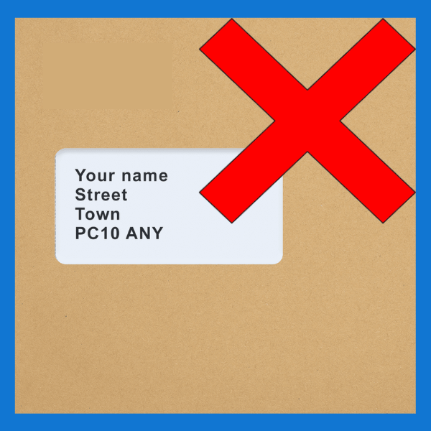 | Question 8.  Would you like us to keep your name or organisation confidential?
 | Yes | ☐
 | No | ☐
Question 9.
If you said yes in question 8,
please tell us why in the box below.
 | Write here

Questions about chapter 1 – the aims of the ABS
Question 10.
How much do you agree with our main aims and ideas for the ABS?
I really agree ☐
I mostly agree ☐
I do not mind ☐
I mostly do not agree ☐
I really do not agree ☐
I do not know ☐

Question 11.
What do you think is the most important thing that the ABS could make better?
Write here

Question 12.
You can tell us anything else you want to say about Chapter 1 in the space below.
Write here

Chapter 2 questions – how students will study
Question 13.
Level 3 ABS has 2 programmes.
How much do you agree with these plans?
I really agree ☐
I mostly agree ☐
I do not mind ☐
I mostly do not agree ☐
I really do not agree ☐
I do not know ☐

Question 14.
Level 2 ABS has 2 programmes.
How much do you agree with these plans?
I really agree ☐
I mostly agree ☐
I do not mind ☐
I mostly do not agree ☐
I really do not agree ☐
I do not know ☐

Question 15.
You can tell us anything else you want to say about Level 2 ABS in the space below.
Write here

Question 16.
Do you have any ideas how we can support students in the 1 year Transition Programme
to move up to Level 3?
Write here

Question 17.
What levels do you think we should
have in the ABS?
Tick 1 box only.
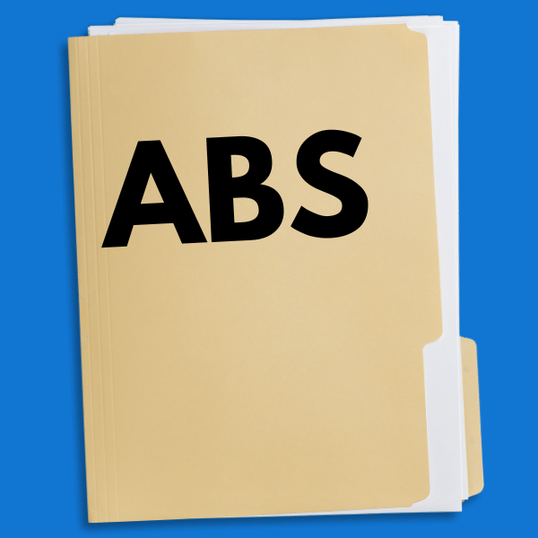 | Both Level 2 and Level 3 in the ABS.  But it does not need to say what level  a student is. | ☐
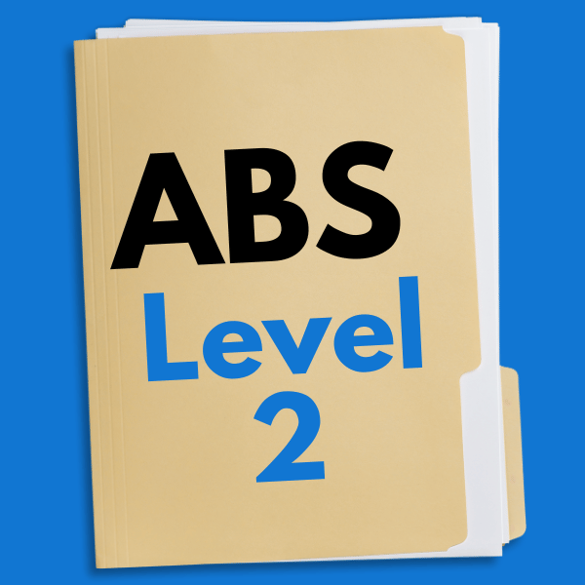 | Both Level 2 and Level 3 in the ABS.  But it should say if a student is Level 2 or 3. | ☐
 | Level 2 programmes should have a different name. | ☐
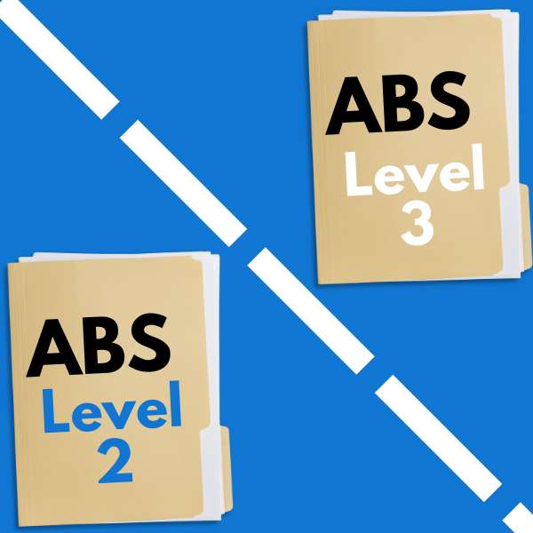 | Level 2 programmes should be separate from Level 3. | ☐
 | I do not know. | ☐

Question 18.
How much do you agree with our plans for Level 1 and Entry Level students?
I really agree ☐
I mostly agree ☐
I do not mind ☐
I mostly do not agree ☐
I really do not agree ☐
I do not know ☐

Question 19.
Do you have any ideas how extra teaching time can be used to support Level 1 and Entry Level students?
Write here

Question 20.
In the future, all students will do the ABS instead of other Level 3 courses like A Levels and T Levels.
What do you think about this?
Write here

Question 21.
How much do you agree with how students can choose subjects for the Level 3 ABS programmes?
I really agree ☐
I mostly agree ☐
I do not mind ☐
I mostly do not agree ☐
I really do not agree ☐
I do not know ☐

Question 22.
How much do you agree with how students can choose subjects for the Level 2 ABS programmes?
I really agree ☐
I mostly agree ☐
I do not mind ☐
I mostly do not agree ☐
I really do not agree ☐
I do not know ☐

Question 23.
Do you have anything else you want to say about Level 2 or Level 3 subjects?
Write here

Question 24.
We plan to make sure students can spend more time with teachers.
This is instead of learning on their own.
How much do you agree with these plans?
I really agree ☐
I mostly agree ☐
I do not mind ☐
I mostly do not agree ☐
I really do not agree ☐
I do not know ☐

Question 25.
Do you have anything else to tell us about how many hours students should get for each subject?
Like if students should have the same amount of time for each subject.
Write here

Question 26.
Do you have any ideas about how to make
EEP sessions better for students?
EEP are activities that help students get skills
for work and life.
We want your ideas about how we can help students who need extra support.
Write here

Question 27.
Do you have any ideas about
- how we can get more employers to offer work placements to students?
- what other support schools and colleges will need to help find work placements for students?
Write here

Question 28.
How much do you agree with our principles for English and maths?
I really agree ☐
I mostly agree ☐
I do not mind ☐
I mostly do not agree ☐
I really do not agree ☐
I do not know ☐

Question 29.
How much do you agree with our plans for knowledge and skills for maths and English?
I really agree ☐
I mostly agree ☐
I do not mind ☐
I mostly do not agree ☐
I really do not agree ☐
I do not know ☐

Question 30.
How much do you agree with our plans to have majors and minors for English and maths at ABS Level 3?
I really agree ☐
I mostly agree ☐
I do not mind ☐
I mostly do not agree ☐
I really do not agree ☐
I do not know ☐

Question 31.
We want to help 16 year olds who got low marks in English and maths to go on to study these subjects at Level 3.
Have you got any ideas on the best way
to support them?
Write here

Question 32.
We want to help students on the Occupational programme to do better at English and maths.
Have you got any ideas on the best way to support them?
Write here

Question 33.
Do you have any ideas on how we can use Level 2 courses like GCSEs in the new Level 2 ABS?
Write here

Question 34.
Do you have any idea about our plans in Chapter 2?
Write here

Questions about chapter 3 – tests and grades
Question 35.
Our ABS aims and principles help us test students doing the ABS.
How much do you agree with these?
I really agree ☐
I mostly agree ☐
I do not mind ☐
I mostly do not agree ☐
I really do not agree ☐
I do not know ☐

Question 36.
How much do you agree with our plans to grade students’ work on the ABS?
I really agree ☐
I mostly agree ☐
I do not mind ☐
I mostly do not agree ☐
I really do not agree ☐
I do not know ☐

Question 37.
How much do you agree with our plan to give grades for each major and minor subject that students do on the ABS?
I really agree ☐
I mostly agree ☐
I do not mind ☐
I mostly do not agree ☐
I really do not agree ☐
I do not know ☐

Question 38.
Do you agree that students should get the ABS Award as well as grades for each subject?
Tell us why.
Write here

Question 39.
What grades should a student need to get a Level 3 ABS award?
Tick one box only
 | Students should pass all subjects at Level 3. But they only need Level 2 for English and maths. | ☐
 | Students should pass English, maths,  and all other subjects at Level 3. | ☐
 | Students should pass some majors and some minors. For example, 3 majors and 1 minor. | ☐
 | When you add a student’s grades together, it is above a minimum score. | ☐
 | Students should not need to pass a minimum number of subjects. | ☐
 | I do not know. | ☐
 | Something else. Please tell us below. | ☐
 | Write here

Question 40.
Which of the 3 ideas for the ABS Award on
page 16 of the consultation booklet do you like the most?
Write here

Question 41.
Do you have any other ideas on how to test and grade students?
Write here

Chapter 4 questions – changes for schools and colleges
Question 42.
What do you like about education for 16 to 19 year old students and think we should keep?
Write here

Question 43.
We want to employ more teachers for the new ABS.
What do you think could happen if we do this?
These might be good or bad things.
Write here

Question 44.
What training will staff need to get ready for
the ABS?
Write here

Question 45.
We want to understand all the changes we might need to make for all students when the ABS starts.
Like for students with SEND.
What changes do you think we will need to make at schools and colleges?
Like changes to buildings and transport.
Write here

Question 46.
Do you have any other ideas about the changes that education providers might need to make for the ABS?
Write here

Chapter 5 questions – what the ABS will mean for all
Question 47.
What changes do you think we will need to make to education for students under 16 years old for the ABS to work well?
Write here

Question 48.
Do you have any ideas about how we can help students to make good decisions about their ABS or apprenticeship?
Write here

Question 49.
Do you have any ideas about the extra support students with SEND might need to do the ABS?
Write here

Question 50.
Do you have any ideas about how we can support other groups of students that might have extra needs?
For example, students who are carers.
Write here

Question 51.
We want the ABS to help students to carry on with education after 18 if they want to.
Do you have any ideas about how we can support ABS students to do this?
Write here

Question 52.
We want the ABS to help young people get good jobs.
Do you have any ideas how we can
make sure the ABS is useful for employers?
Write here

Question 53.
Do you have any ideas about what the ABS means for other groups of students over 16 years old doing other courses?
For example
- adult students in further and community education
- students doing qualifications in other countries.
Tell us in the space below.
Write here

Question 54.
What do you think the ABS will mean for students with a protected characteristic?
This can be good or bad.
Write here

Question 55.
What do you think the ABS will mean for the environment? This can be good or bad.
Write here

Question 56.
Do you want to tell us anything more about our plans in Chapter 5?
Write here

Question 57.
Do you want to tell us anything else about the ABS that we have not asked in this booklet?
Write here

Thank you for doing our survey.
We will use what you say to make our plans for the Advanced British Standard better.
If you have any questions about this consultation, you can email ABS.consultation@education.gov.uk
Crown copyright [2023].
Document reference CP991.

